Name: V.SUPRIYA
Reg.no:192472340
COURSE CODE: CSA1111

OOAD LAB EXPERIEMNTS

Exp-1 PASSPORT AUTOMATION SYSTEM
AIM:
To draw the diagrams [use case, activity, sequence, collaboration, class, state chart, collaboration, component, deployment, package] for the Passport Automation System.
HARDWARE REQUIREMENTS:
Intel Pentium Processor I3/I5
SOFTWARE REQUIREMENTS:
Rational rose /Argo UML
PROCEDURE
- Open Umbrello and create a new project.
- Select the required UML diagram (Use Case, Class, Activity, Sequence or Package).
- Add the necessary elements related to the Passport Management System.
- Connect the elements using appropriate relationships.
- Arrange the diagram neatly and verify the connections.
- Save the completed diagram.

Name: A.V.Ameya
Reg.no:192472036

USE CASE DIAGRAM
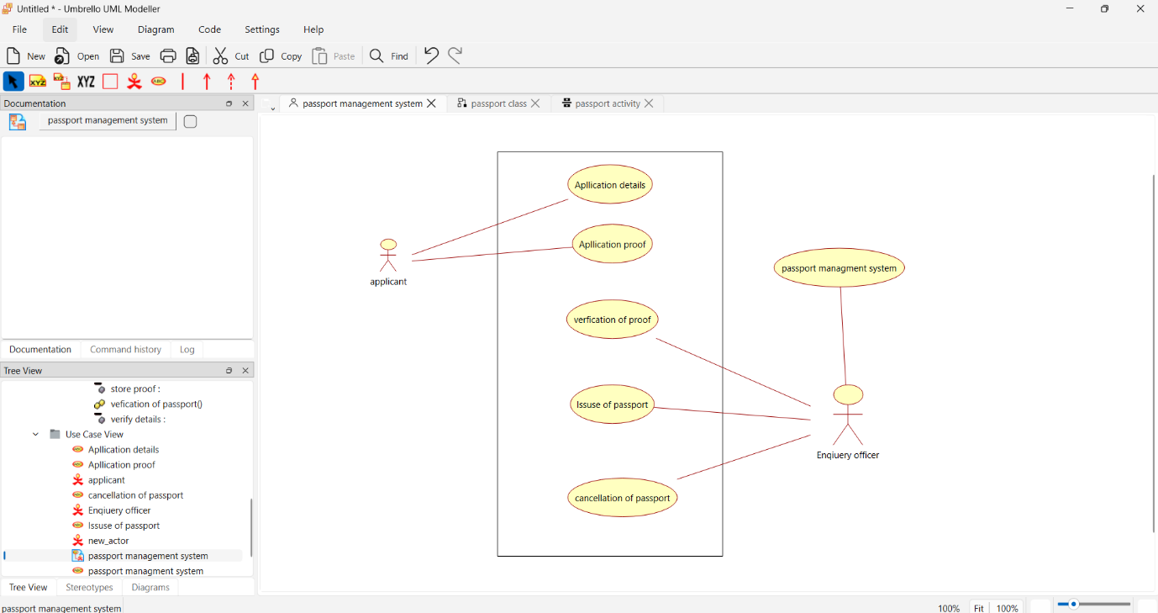
CLASS DIAGRAM
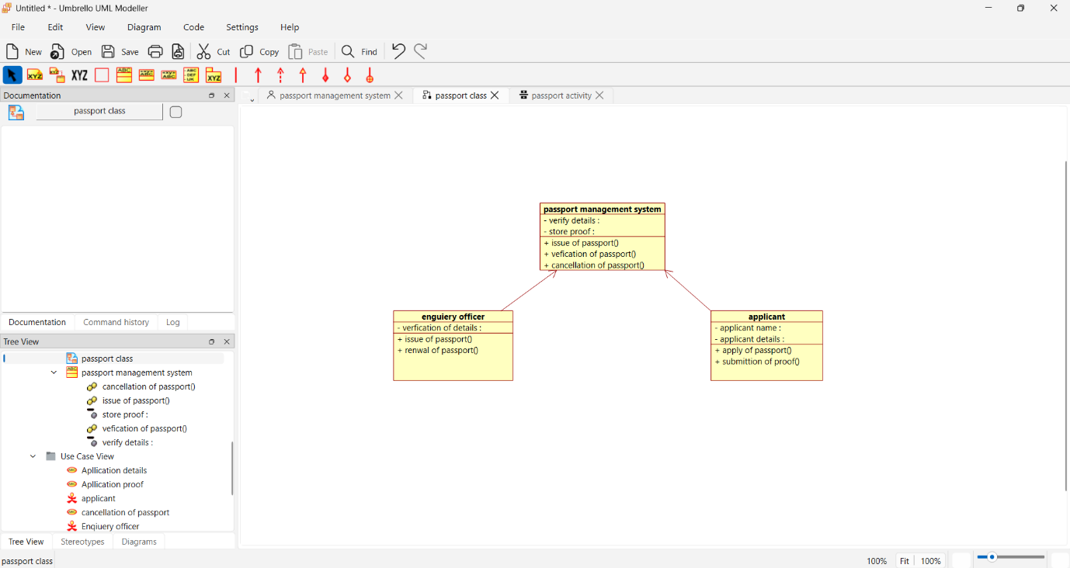
Name: A.V.Ameya
Reg.no:192472036

ACTIVITY DIAGRAM
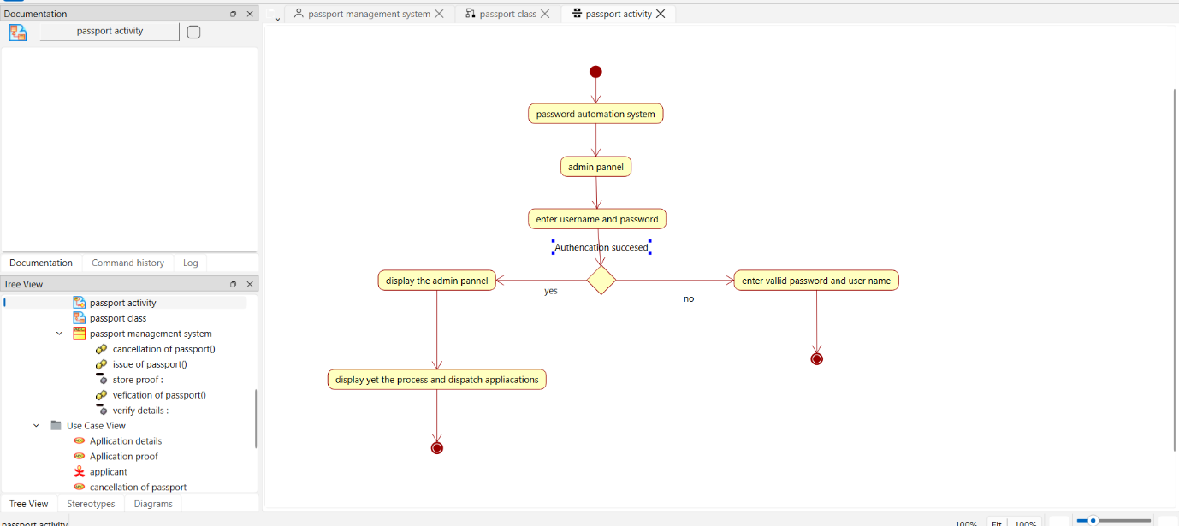
SEQUENCE DIAGRAM
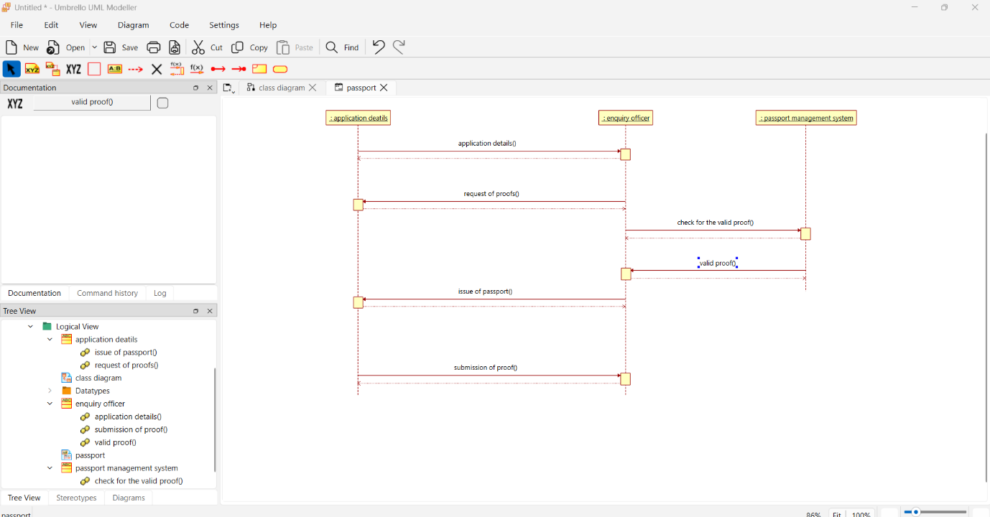

Name: A.V.Ameya
Reg.no:192472036

PACKAGE DIAGRAM
